02/02/2024 – Created a simple level with a simple player controller

03/02/2024 15:43 – Attempting to create a interaction mechanism for moving objects around, opening doors and whenever the player needs to interact with the environment. Currently not working as the ray is casting from the player and not the camera.

03/02/2024 15:46 – moved interaction script to the camera and now the ray is casting from the camera. Now I need to program something which can handle interactions and make it obvious the object can be interacted with.

03/02/2024 16:02 – Player can see if an object is interactable. Errors are from when Raycast hit is null. I’m not sure how to check if Raycast hit has a value or not so those errors are staying for now.

03/02/2024 16:10 – found a fix for above issue. A bool can be used to store if the raycast had hit anything. I can use the bool to check is the raycast has value and only execute further code if there is value so the errors are gone now.

04/02/2024 – Started creating the reaction part of an interaction, the play can see if an object is interactable but cant actually interact with it. I need objects that can be moved around for things like setting up a stage, have an animation for things like doors opening and to be able to be put in an inventory for things like storing keys.

04/02/2024 15:19 – im using a rough system here to implement the interaction system I want. The player can move objects around but they can also move them out of bounds.

07/02/2024 10:12 – with interactions, im thinking I wont be able to consolidate everything into a few number of scripts.

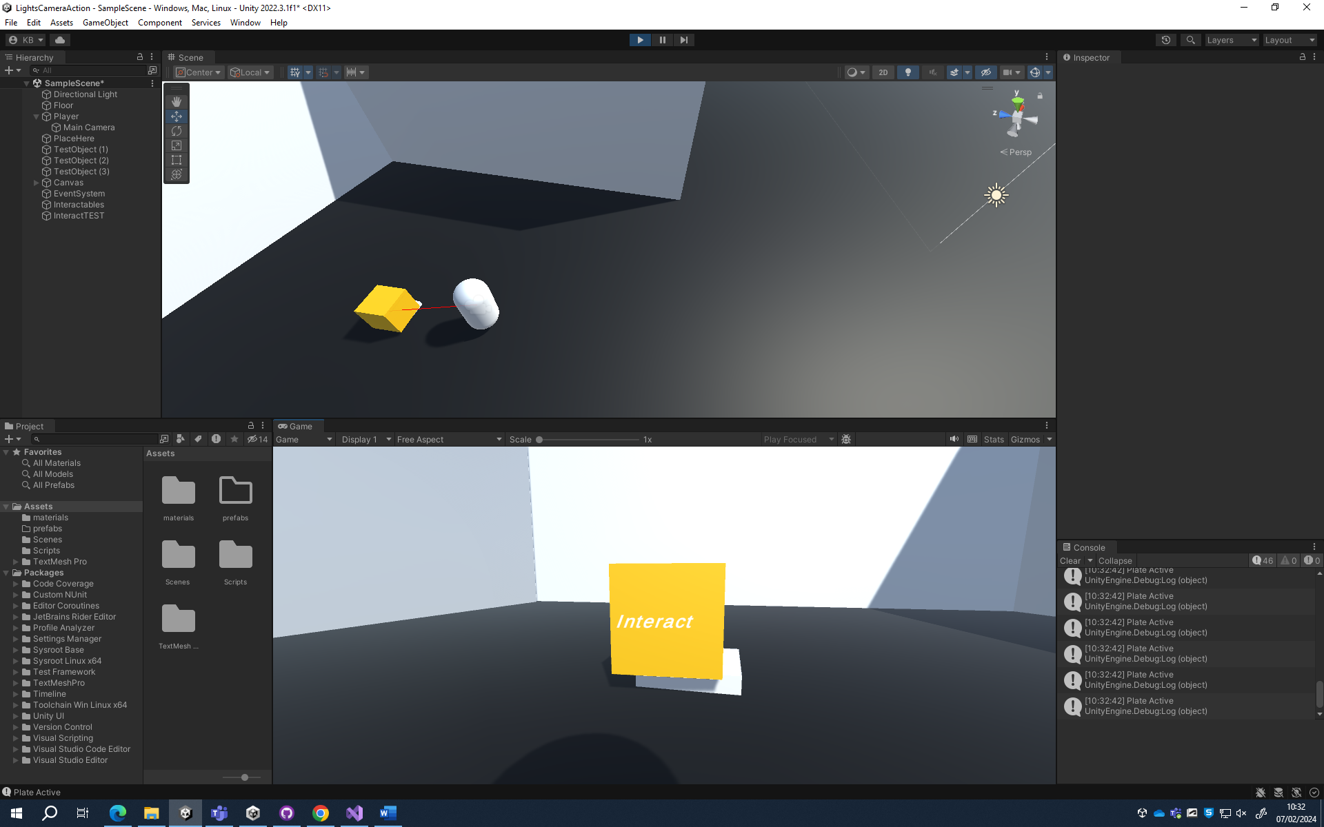

07/02/2024 10:33 – made a pressure plate, this will be used to check if the player has placed an object and will activate things later

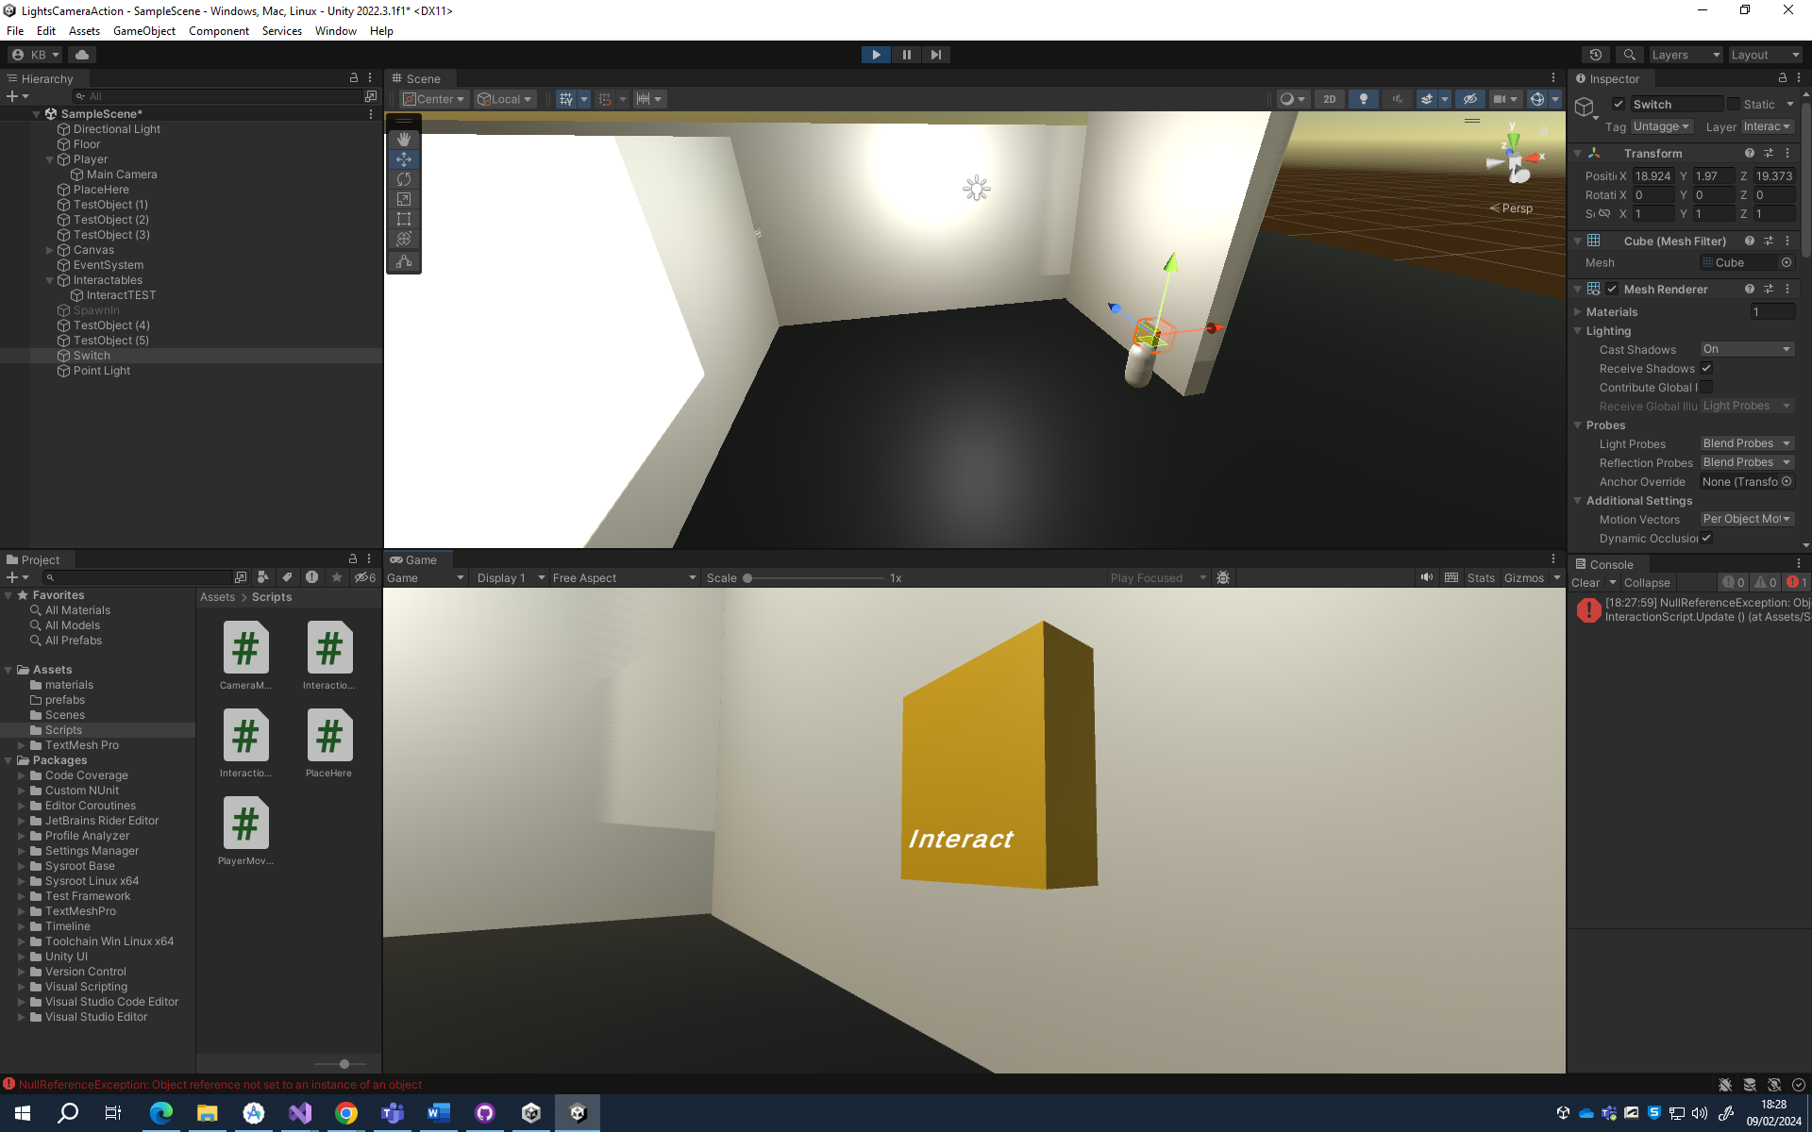

09/02/2024 18:30 – made a light switch, it can be used to switch power on in the main level

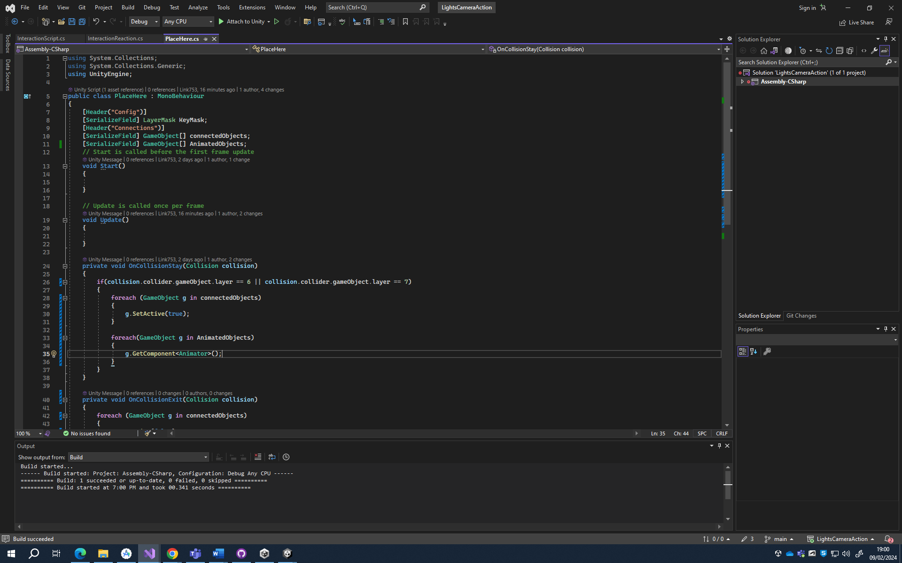

09/02/2024 19:01 – lines 33 to 36 will be for animated objects, eg an entity looking at you or something moving.

10/02/2024 16:49 - I made a pressure plate for the player

21/02/2024 10:06 – added synoptic report

14/02/2024 – began creating a basic camera model in blender

06/03/2024 09:47 – realised I left the blender model on my home pc and didn’t commit changes to github. Started to create a portable camera that the player takes with them. The idea is they are documenting crime scenes left behind by a serial killer and they decide to document previous crime scenes on their own. Idea is that while documenting, something stalks them and may mess with them.

08/03/2024 - Created an imported a camera model from blender!

11/03/2024 13:00 – I have made a portable camera that can see things that the player may not be able to see.

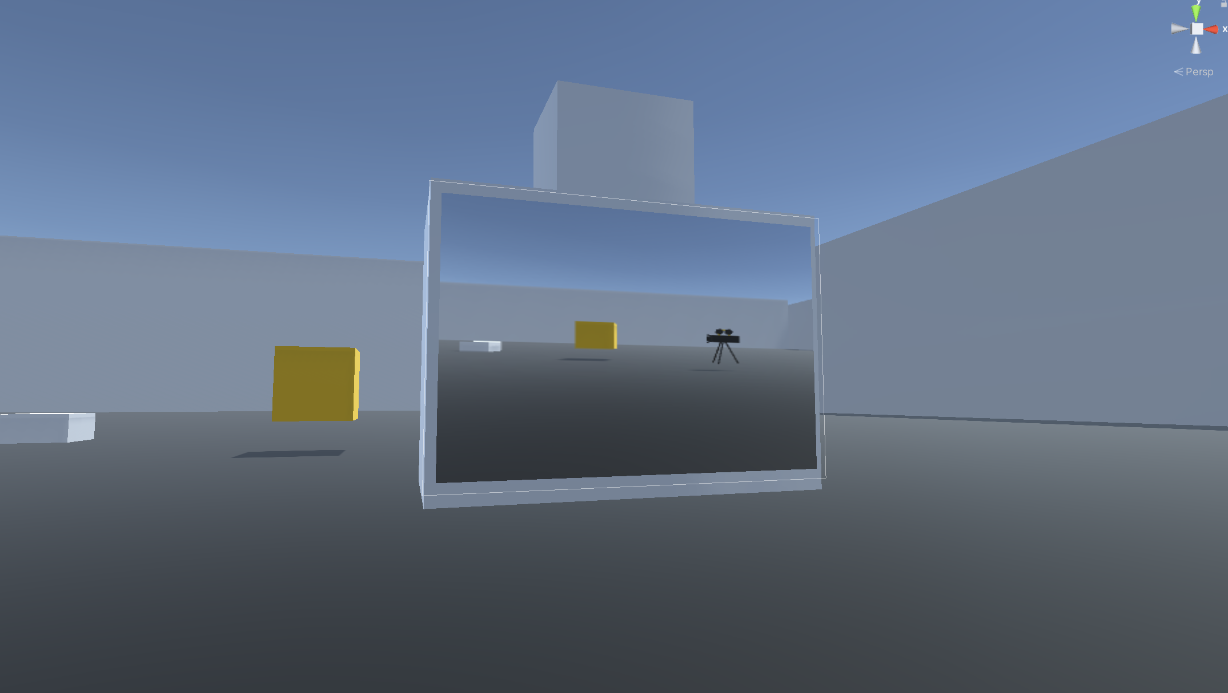

The idea is that the player is documenting a location and the camera may be able to capture things the player can’t see

11/03/2024 13:44 – I wanted to add a feature where the player can capture images but that doesn’t seem possible in unity so ive come up with a work around where the camera will save everything on a floor and that floor can be recreated in real time so it looks like an image is saved

11/03/2024 14:31 – Mechanics for saving object are built but not implemented yet. I will be working on this saving feature for some time

13/03/2024 – didn’t document this but I tried to make a complicated saving system where all objects in a room save when the player takes a picture. Then when it loads a picture, it would recreate the room and display it to a render texture object

14/03/2024 12:03 – Scrapped previous system as it would make the hierarchy too complicated and would make development too difficult. Now all that will be saved is the room prefab and camera properties.

15/03/2024 18:50 – tried to take a picture through the savesystem. Currently broken as library didn’t build correctly and unity fails to serialize the data

17/03/2024 17:11 – the data can now be serialized and saved. Ran into an issue where gameobjects cant be serialized but fixed by creating a list of expected names and comparing them. Loading is an issue as a value keeps returning null for some reason

28/03/2024 16:31 – Ive not updated this for a while but ive got the saving pictures and loading pictures fully working and failsafes are in place incase the player tries to load a file that doesn’t exist. Also got an entity working where it will be looking at the player then if the player tries to take a picture of it multiple times, it will chase the player. Also ive laid the groundworks for saving the game as a whole. Next steps are to create UI elements that will make game run in a loop, sounds need to be created and implemented, models need to be either sourced or created, levels need building and the game needs a thorough bug fixing/ player testing done.

28/03/2024 16:52 – found out unity doesn’t bake lighting when loading scenes using scenemanager so had to generate lighting for the main scene

28/03/2024 17:14 – building the UI on main scene to test if the game is looping. I still need to write UI scripts

29/03/2024 17:05 – UI scripts on both the starter scene and main scene are completed and are fully working

29/03/2024 18:20 – building the monitoring room and considering using kenny’s assets